Software Requirements Specification
For
AUTOMATED ATTENDANCE SYSTEM USING ANDROID DEVICE
Prepared by
Jaya Shankar Reddy Kommuru 411529
Vishnu Nagineni 411551
V.Sai Prathyush 411576
NIT Andhra  17-11-17
Table of Contents
Table of Contents ii
Revision History ii
1. Introduction 1
1.1 Purpose 1
1.2 Intended Audience and Reading Suggestions 1
1.3 Project Scope 1
1.4 References 1
2. Software Requirements 2
2.1 Problem Definition 2
2.2 Modules 2
2.3 Modules' Functionalities 2
3. External Interface Requirements 4
3.1 User Interfaces 4
3.2 Hardware Interfaces 4
3.3 Software Interfaces 4
3.4 Communications Interfaces 4
4. Other Nonfunctional Requirements 5
5.1 Performance Requirements 5
5.2 Safety Requirements 5
5.3 Security Requirements 5
5.4 Software Quality Attributes 5
5. Sofwtare Design 5
5.1 Class Diagram 5
5.2 Use Case Diagram 5
5.3 Interactive Digrams 5
5.4 Activity Diagram 5
5.2 State Chart Diagram 5
5.3 Component Digrams 5
5.4 Deployment Diagram 5

6. Testing 5
5.1 Unit Testing 5
5.2 Integration Testing 5
5.3 Black Box Testing 5
5.4 White Box Testing 5

6. Other Requirements 5
Appendix A: Glossary 5
Appendix B: Analysis Models 6
Appendix C: Issues List 6

Introduction

Purpose

The Purpose of the product is to make the college campus paper free. To automate the tasks performed by the faculty in order to manage the functionalities of the college. Also for the students who desire not to waste the time and spend their total time in academics.

Intended Audience and Reading Suggestions
This SRS is intended to the students and faculty of a college so that they can understand how to use the app and how the app works in the back end.

Project Scope

Short description: The android application is for the students to upload the attendance, view results
and receive notifications from the college. The faculty can update the daily timetable and the admin can send the notifications to the users.

The app can be used by any College which has desire to automate its functionalities.

Benefits: Automation, Reduce man power, low cost

Objectives: Comfortable user interface, fast loading and refreshing.

Goals: The Goal is to integrate all the college management features in our android app. And also to provide the best performance and response time..

References
https://developer.android.com/index.html

https://android-developers.googleblog.com/

Software Requirements

Problem Definition
The main contribution goes to reduce the manual work involved in taking attendance by most of the college. They either use camera, voice recognition as to identify students uniquely. But such solutions are costly. The software built addresses the problem by using fingerprint and GPS sensors available in the students’ mobiles. Also the students can view their attendance report any time and beware of attendance shortage.

Other problem is the manual work involved in the notice board. The management should first keep notice on the notice board and the students should daily check if there are any new notifications for them. Also there is a wastage of paper involved in that. The application addresses this problem by sending the users notifications in chunks using the firebase cloud. The students receive notifications in no time.

Modules

- Automated attendance system

- College Notifications to students and Faculty

- Results upload by faculty and viewed by students.

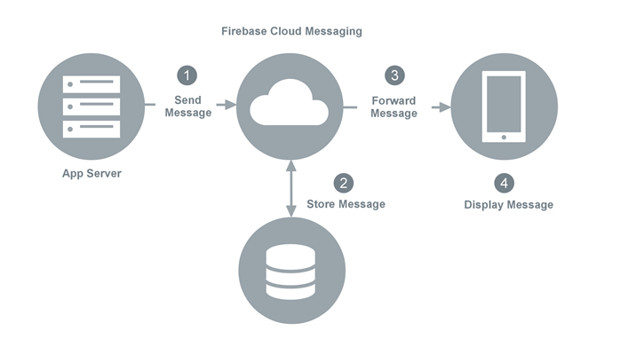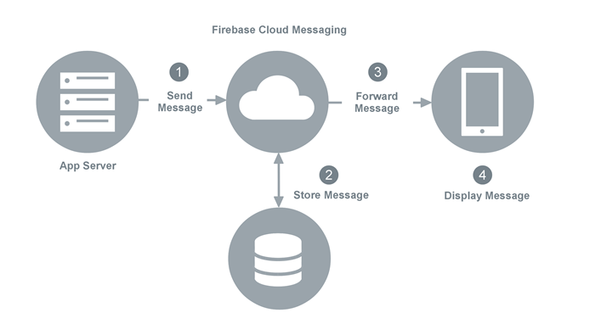

Modules’ Functionalities

Automated Attendance Module:
This module needs fingerprint sensor and gps of mobile.

The database stores the latitude, longitude and altitude ranges of the classrooms in the college. The user of the application is prompted to touch the fingerprint. An Symmetric key pair is generated where public key is being stored in database. For this cryptographic encryption, RSA encryption algorithm has been used.
Once done with the fingerprint authentication, the user is requested to access his location service in run time. The user responds to our request and his current latitude, longitude and altitude values, time are retrieved and compared with the classroom’s values and give attendance to the course corresponding to the time in timetable.
In this way, the student can upload his attendance.

Notifications Module
The admin sends the notifications to the app server. As the app being connected to Google firebase, all the notifications are sent to firebase.

Firebase needs to identify each user of the app uniquely. For this a token named fcm_token is to be obtained from each user. The option to whether to receive notifications or not is decided by the user. If the user sent the fcm_token to the firebase, then all the notifications sent to firebase will be sent to the user automatically.

Results Module
The Faculty/admin can upload the results to the database as soon as the correction work is completed. Then the students can view their results any time in no time. This reduces the work of students and faculty both.

Login and Register (OTP ) Module
These are the obvious modules just as like all applications. The registration of a student is done only through OTP verification as all the students register their mobile numbers with admin. The password storing in the database is done with a random hash so that the admin also cannot login into students’ or faculty’s accounts.

The OTP is also sent by the Google firebase cloud. The http requests for login, register, OTP, sending tokens is done through VOLLEY library which makes connections fast, easier and concurrent.

External Interface Requirements

User Interface:

The User Interface for the students and faculty will be a mobile app . And for the admin, it will just be a web interface to login.

The UI for the students and faculty is built through XML support through Android Studio. There will be no lag in communication with the app and database server as volley library is being used.

The UI for the admin is built in HTML and linked to database through php files.

Software Interfaces
- Java
- XML
- PHP
- HTML
- phpmyadmin
- MYSQL
- Android SDK

Hardware Interfaces
- Fingerprint sensor: To uniquely identify the student to mark attendance. This interface is inbuilt for the above android 6.0 devices
- GPS for location: To track the latitude, longitude and altitude values of the users’ location. This feature is in built in most android devices.
- Web server
- Android device (mobile, tab, etc.,)

Communication Interfaces
COM.ANDROID.VOLLEY: For connection between server and android device using HTTP Protocol.

Other Nonfunctional Requirements

Performance Requirements

Reponse time: The access time for a mobile device should be less than a minute.The system should respond to the member in not less than two seconds from the time of request submittal.The system shall be allowed to take more time when doing large processing jobs.
.
Capacity: The system is capable of handling more number of users at a time.

Resource Utilization: The resources are modified according to the user requirements.

Reliability
The server that has been used is a free hosted one and all the files are stored in it. Also the backup for all these is also to be stored in local server.

Operational Requirements
- The students and faculty use their own android devices.
- Internet permission
- Location access permission
- Access fingerprint permission
- The android version to be 6.0 and above.
- The admin uses PC for sending notifications and update time table.

Testing

Unit testing
All the modules have been independently tested and tested through all inputs.
The testing is mainly devoted to the login and registration module.
The Screenshots for different inputs of login and registration modules are given below along with the suggestions.

Integration testing
All the modules have been integrated and tested entirely.

White box testing
A sample demo video of white box testing has been created and presented in the ppt.

Test cases:
